PASSPORT MANAGEMENT SYSTEM:-

USECASE DIAGRAM:

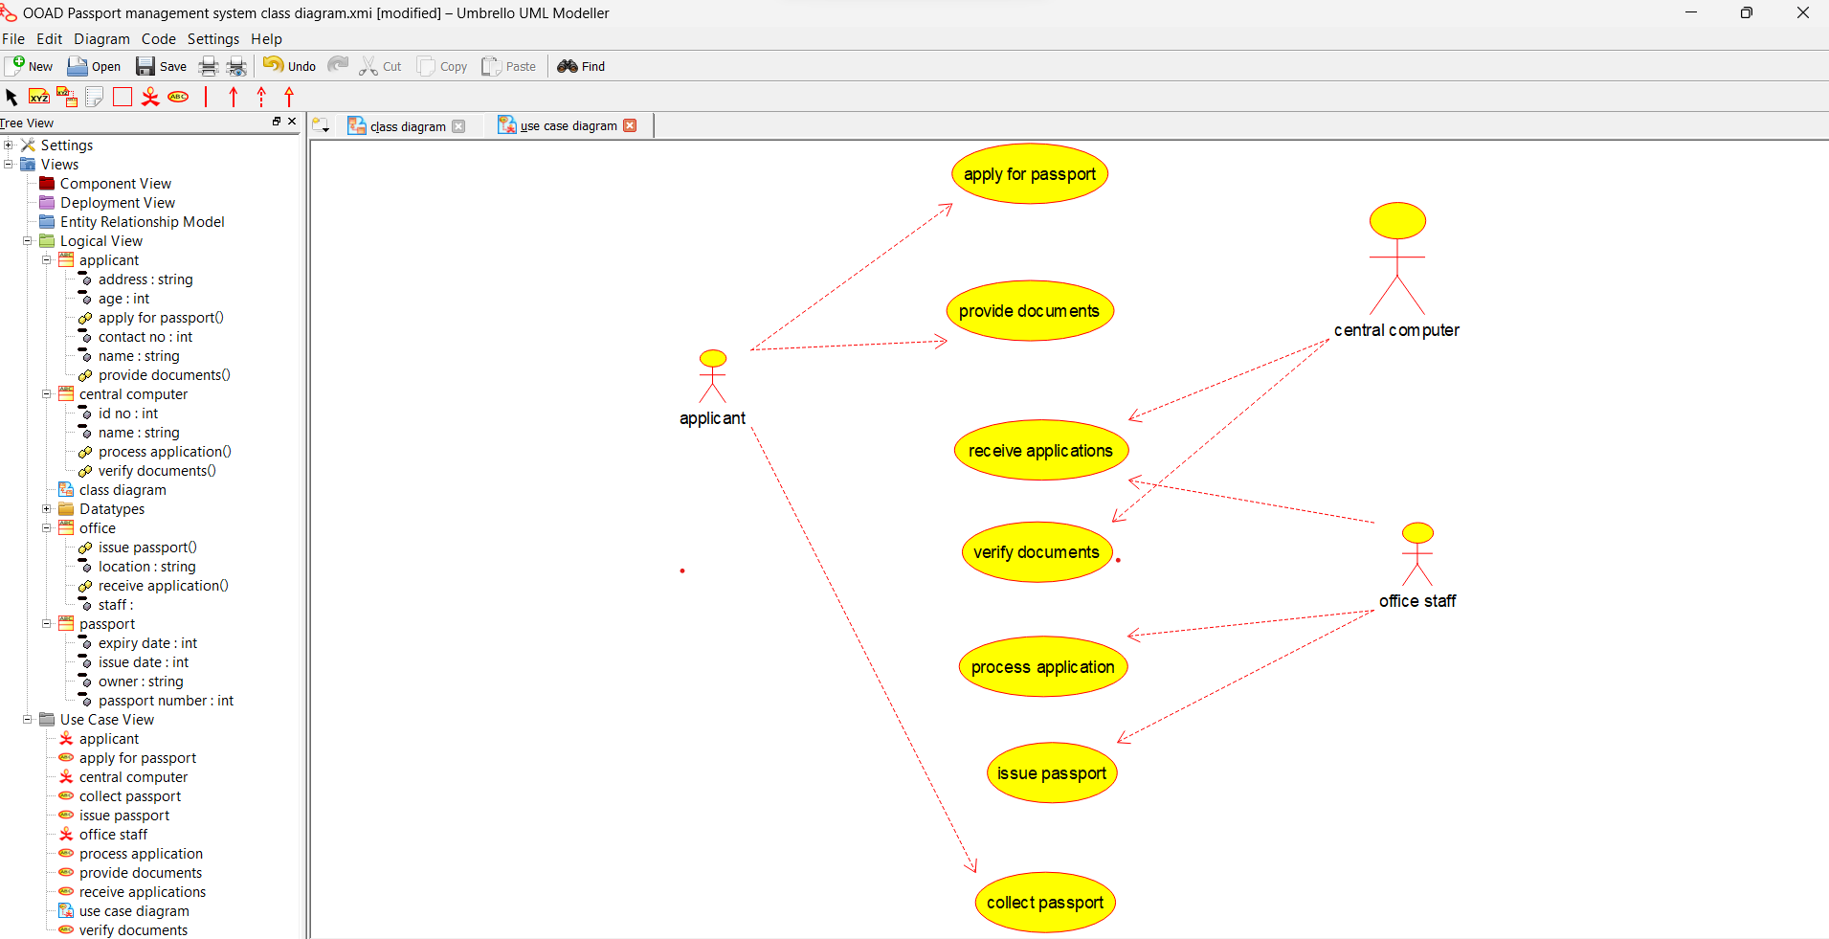

CLASS DIAGRAM:

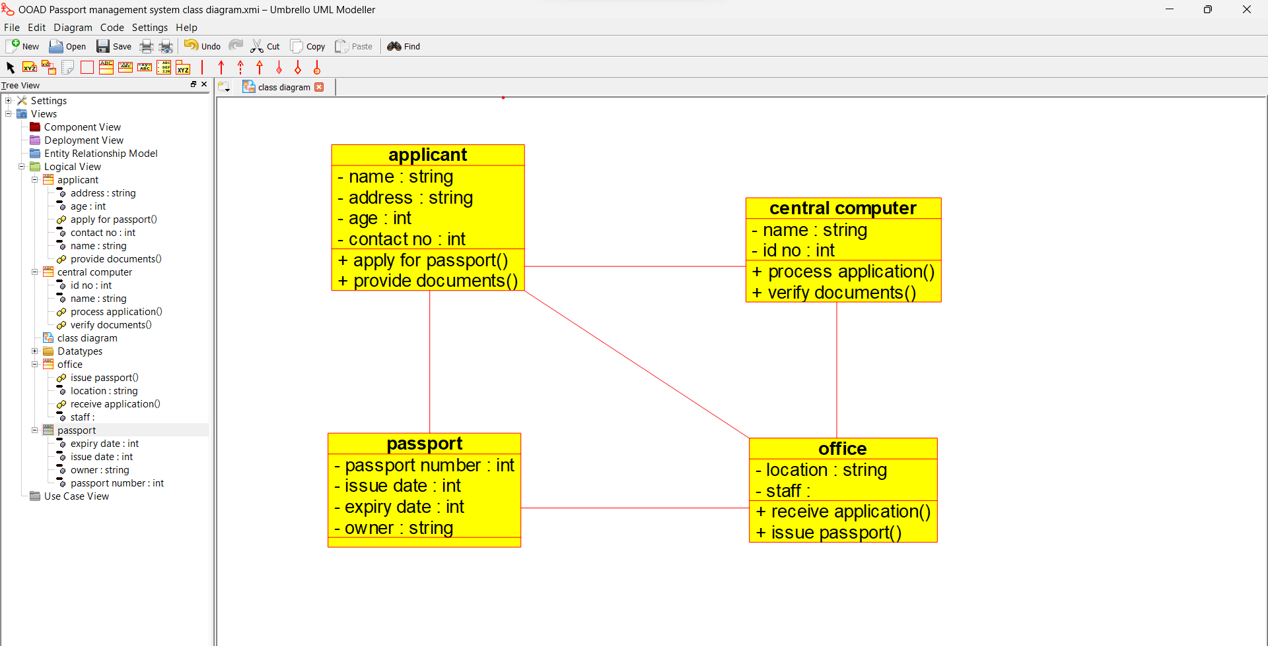

BOOK BANK PROCESS**:-**

USECASE DIAGRAM:

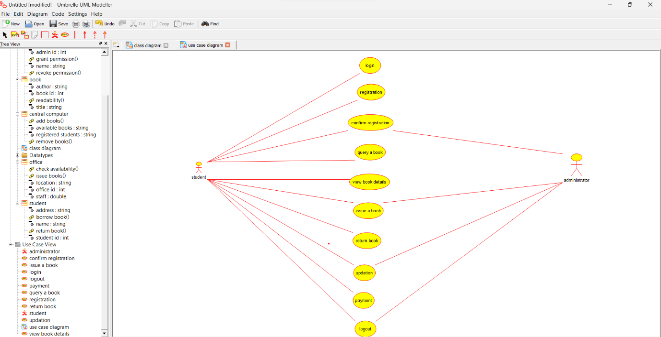

CLASS DIAGRAM:

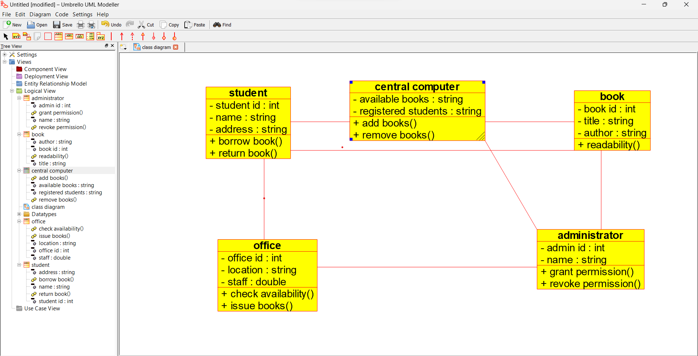

ACTIVITY DIAGRAM:

